Welcome to the Univeristy of Southampton

We hope you enjoy your visit.
Please see below instructions on how to reach us by car or public transport
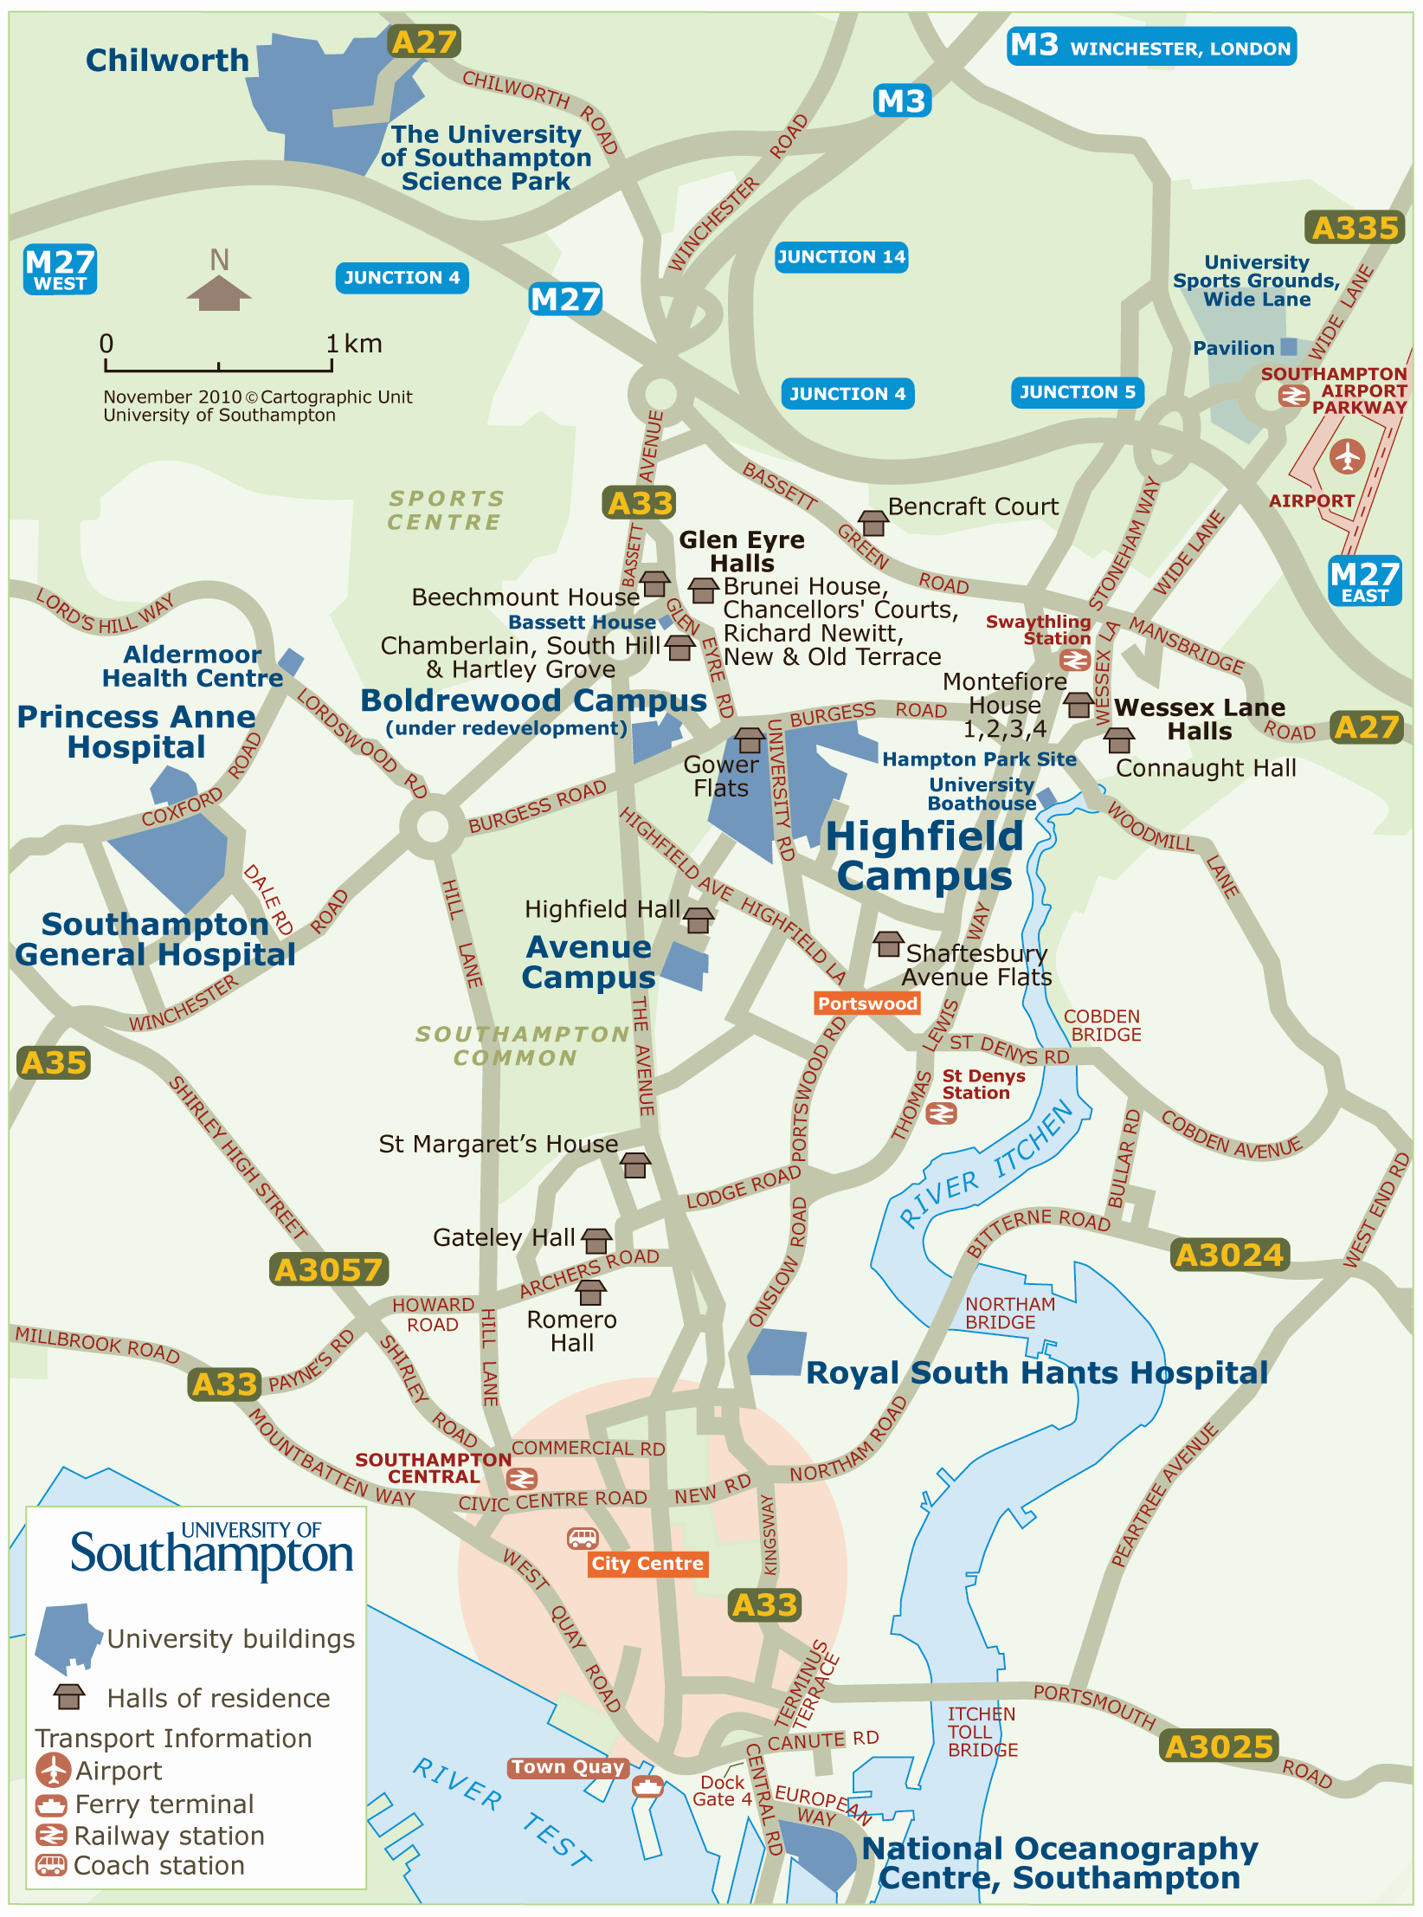
Travel by Car to the University Campus


Driving on M3:
- At Junction 13 take right-hand lanes to continue forward onto the M3 (signs for Southampton A33)
- Leave the M3 at junction 14, then merge onto the A33
- At Chilworth Roundabout take the 2nd exit onto the A33
- Follow the A33 (Bassett Ave.) take 1st exit on next roundabout – continue along A33, keep in left hand lane
- At major intersection, turn left at traffic lights onto A35 (Burgess Road)
- Continue through two set of lights past Shell garage on left hand side
- Keep in right hand lane – at third set of traffic lights turn right into University Road

From the M27:
- Leave the M27 at junction 5
- If coming from the east, take the 1st exit off the roundabout; if coming from the west, take the 4th exit (onto A335)
- Follow the A335 dual carriageway through 2 sets of traffic lights
- At the 3rd set, turn right onto A35 (Burgess Road) - McDonald's will be on your left
- Continue through one sets of traffic lights
- Keep to left hand lane and turn left at the traffic lights onto University Road

University parking:
The Hampton car park is indicated in red on the map below just off Burgess Road (top right-hand corner). The disabled car park is also indicated in red just off University road. It is referred to as ‘pre-booked parking’. You must display your visitor car parking permit if you park here. Limited permits are available on request at asmcf14@soton.ac.uk.

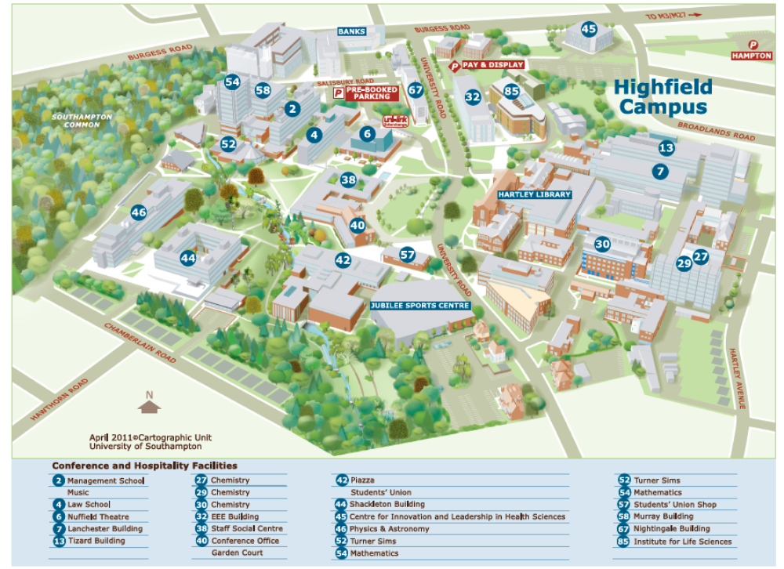

Travel by Rail to the University Campus

Southampton has two main train stations:

  - Southampton Central; located in the city centre

  - Southampton Airport Parkway; located outside of the city next to the airport and M27 motorway

Train times can be found at:
www.nationalrail.co.uk Telephone - 08457 48 49 50
www.thetrainline.com Telephone - 0871 244 1545

These stations are approximately 2½ -3 miles from the University of Southampton, so you will need to use public transport to get to the campus.

The University Uni-link bus service runs from the Airport Parkway train station and Southampton Airport to the main Highfield Campus (please visit their website for timetables and locations www.unilinkbus.co.uk)

Charge of £2.00 per adult for a single journey / £3.00 for adult unlimited travel for one day

Local Taxis also operate outside the train stations.

Travel time approximately 10 –15 minutes from the University of Southampton. Charge approximately £7-£10

You don’t usually need to pre-book taxis but if you want to book - here are a couple of numbers you may like to try:

Local Taxi Numbers -
Radio Taxi’s – 023 8066 6666
Streamline Taxi’s – 023 8022 33 55
West Quay Cars – 023 8022 3450


Travel by Air to the University Campus

Southampton Airport Information can be found at www.southamptonairport.com

Your Onward Journey:

By Taxi
Southampton Airport taxis are operated by Checker Cars.
Checker Cars operates a 24-hour taxi service from Southampton Airport and has an office opposite the arrivals hall. Some cars have swivel seats for easier access and there is a minibus suitable for wheelchair users. Should you require either of the above options, please pre-book your journey by calling +44 (0)2380 62 7100 or email Southampton@checkercars.com
To take a taxi from the airport, please go to the taxi desk in the main concourse, near the exit. Your car will then pick you up outside the terminal building.
The fare to your destination is fixed in advance, and you can pay either at the time of booking (credit and debit cards accepted) or at the end of your journey (cash only).

By Bus
The Uni-link U1C operates from the Airport to the University, city centre and eastern docks. It runs every 15 minutes during the week and every 20 minutes at weekends and on public holidays. For details, visit the website www.unilinkbus.co.uk or call +44 (0)2380 595 974.

Halls of Residence

The Halls of Residence (Highfield Hall and Glen Eyre Complex) are located approximately ½ mile from the main Highfield Campus.

When you arrive at the Halls of Residence – you will need to go to the 24-hour Reception to collect your room key, access code and Welcome Pack.

GLEN EYRE COMPLEX
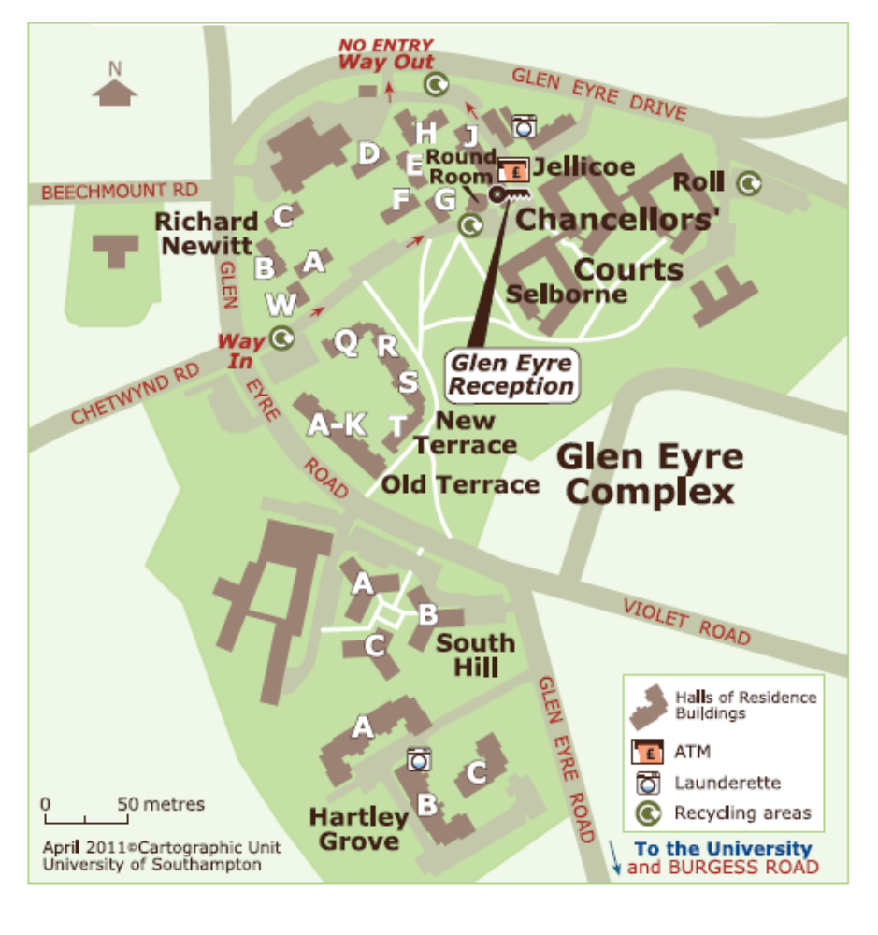

If you are staying at Glen Eyre Complex, your bedroom accommodation may be on the other side of the complex from the Reception area – it is strongly advised that if you arrive by taxi, that you ask the taxi to wait with your luggage whilst you collect your key and then have the taxi drive you on to your accomodation location.

Directions to Glen Eyre Hall of Residence
The Glen Eyre Halls complex is located on Glen Eyre Road at the north side of Southampton.

From the M3 (north)
Coming in towards the north of the city on the M3, leave at junction 14
Bear left, and follow the road which will then merge into the A33 just before the Chilworth Roundabout
At the Chilworth Roundabout, take the second exit onto the A33 (Bassett Avenue)
Follow the A33 for approximately 1 mile, and then turn left into Glen Eyre Road
Follow Glen Eyre Road. Glen Eyre Hall complex will be on your left, South Hill Halls will be on your right further down the road
For Hartley Grove, continue to follow the road past South Hill Halls, and then take the second exit at the mini roundabout. Hartley Grove will be on your right.

From the M27 (East)
Coming in towards the north of the city on the M27, leave at junction 5
At the roundabout, take the 1st exit onto the A335 (Stoneham Way)
Follow the A335 for about a mile
Go straight on at the first set of traffic lights
Bear right at the second set of traffic lights, continuing on the A335, and then head straight on again at the third set of traffic lights, moving into the right hand lane
At the fourth set of traffic lights, turn right into Burgess Road (A35)
Follow Burgess Road for approximately 1 mile, going past the Stile public house, until you reach a set of traffic lights with a Shell Garage to the right. For the Gower Building turn left at The Stile public house and then take the first right. The Gower Building will be on the right.
For Glen Eyre turn right at the traffic lights into Glen Eyre Road and go up the hill
Hartley Grove will be on the left of Glen Eyre Road near the top of the hill.

From the M27 (West)
Coming in towards the north of the city on the M27, leave at junction 5
At the roundabout, take the 4th exit onto the A335 (Stoneham Way)
Follow the A335 for about a mile
Go straight on at the first set of traffic lights
Bear right at the second set of traffic lights, continuing on the A335, and then head straight on again at the third set of traffic lights, moving into the right hand lane
At the fourth set of traffic lights, turn right into Burgess Road (A35)
Follow Burgess Road for approximately 1 mile, going past the Stile public house, until you reach a set of traffic lights with a Shell Garage to the right. For the Gower Building turn left at The Stile public house and then take the first right. The Gower Building will be on the right.
For Glen Eyre turn right at the traffic lights into Glen Eyre Road and go up the hill
Hartley Grove will be on the left of Glen Eyre Road near the top of the hill.

Halls of residence parking
If you are staying at South Hill, Glen Eyre, please use the designated residents’ car park and walk to the conference venue. You will need to request a parking permit at the Glen Eyre reception on arrival. This is only a 10 min walk to the venue.

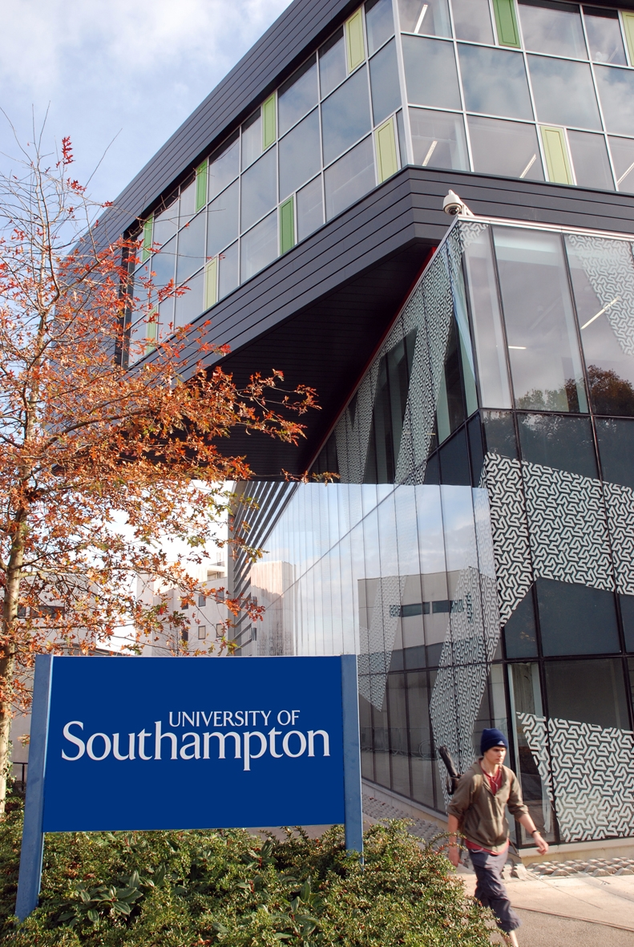
Useful Addresses for University of Southampton

Main University Address (Highfield Campus)
University of Southampton
Highfield
Southampton
Hampshire
SO17 1BJ
Tel: (023) 8059 5000

Avenue Campus
University of Southampton
Highfield Road
Southampton
Hampshire
SO17 1BF

Glen Eyre Halls of Residence
Glen Eyre Road
Bassett
Southampton
Hampshire
SO16 3UF

